**The Bounded Buffer Problem Using Semaphores:**

**The Reader Writer Problem Using Semaphores:**

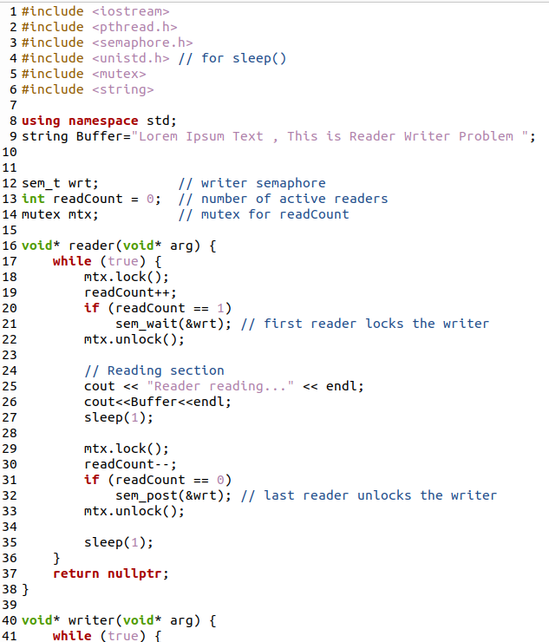

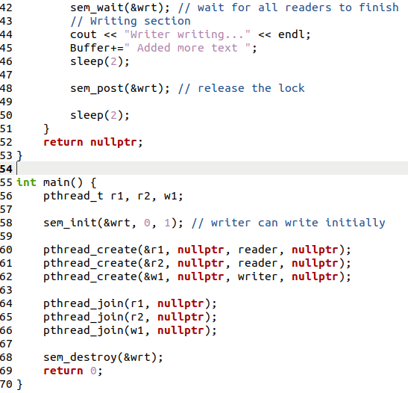

**The Dining Philosopher Problem:**



